Republic of the Philippines

Western Mindanao State University

**College of Computing Studies**

DEPARTMENT OF COMPUTER SCIENCE

Zamboanga City

Gate Keeper: A Game-Based Approach to Logic Gates Learning in Higher and Secondary Education

A Thesis Presented to the Faculty of

Department of Computer Science

College of Computing Studies

In Partial Fulfillment of the Requirements for the Degree of

Bachelor of Science in Computer Science

**JAZHEM M. HAMID**

**DAVE MATTHEW M. IGNACIO**

**EDWIN JR. A. COMEROS**

Researchers

**RHAMIRL B. JAFAAR**

Adviser

<Month and Year of Expected Graduation>

Republic of the Philippines

Western Mindanao State University

**College of Computing Studies**

DEPARTMENT OF COMPUTER SCIENCE

Zamboanga City

# Approval Sheet

The Thesis attached hereto, entitled **“**Game-Based Approach to Logic Gates Learning in Higher and Secondary Education**”**, prepared and submitted by **Jazhem M. Hamid, Dave Matthew M. Ignacio, Edwin Jr. A Comeros** in partial fulfillment of the requirements for the degree of Bachelor of Science in Computer Science, is hereby **recommended for Oral Examination**.

**RHAMIRL B. JAAFAR**

Adviser

**APPROVED** by the Oral Examination Committee on **_______________** with a rating of **PASSED**.

**JAZHEM M. HAMID**

Chairperson

**DAVE MATTHEW M. IGNACIO**

Member

**EDWIN JR. A. COMEROS**

Member

**Accepted** in partial fulfillment of the requirements for the degree of **Bachelor of Science in Computer Science**

**MS. LUCY FELIX-SADIWA, MSCS**

Head, Department of Computer Science

**RODERICK P. GO, Ph.D.**

Dean, College of Computing Studies

# Acknowledgment

This section recognizes the persons and organizations who assisted the proponents in the completion of the thesis. Acknowledgments should be expressed simply and tactfully.

# Abstract

This research project focuses on the creation of an interactive game designed to improve college and high school students' comprehension of logic gates and their problem-solving skills. Traditional methods of truth tables and circuit diagrams often prove challenging for new students, leading to difficulties in grasping and retaining the knowledge. The game is developed to provide a hands-on and intuitive learning experience, aiming to address this persistent issue. The research methodology involved compiling existing educational materials on logic gates, collecting feedback from both students and educators (including frustrations with traditional methods), and analyzing data from game sessions and traditional teaching methods. The game offers various features, including real-time challenges that pit students against each other or the clock, collaborative learning opportunities where students can tackle problems together, customizable matches that allow them to tailor difficulty and focus on specific gates, interactive modules that provide visual representations and animations to enhance understanding, and progressive difficulty levels that ensure a steady learning curve. By incorporating these elements, the game effectively enhances students' understanding of logic gates and improves their problem-solving abilities. This study contributes to the fields of educational technology and computer science education by providing educators with a practical supplementary tool that can make learning logic gates more engaging and effective. It also offers students a beneficial learning resource that can spark their interest in computer science and equip them with valuable critical thinking skills. Future research endeavors could focus on further refining the game's concept to incorporate more advanced logic concepts, exploring additional integration opportunities into formal educational settings through curriculum alignment, and investigating the game's long-term impact on student learning outcomes.

Keywords: Interactive game, logic gates, education, problem-solving, student learning, engagement, pedagogical, innovative, curriculum integration, technology-enhanced.

# Table of Contents

Approval Sheet i

Acknowledgment ii

Abstract iii

Table of Contents iv

List of Figures vi

List of Tables vii

List of Appendices viii

CHAPTER I INTRODUCTION 1

Background of the Study 1

Statement of the Problem 2

Objectives 2

Scope and Limitations 3

Significance of the Study 3

Theoretical Framework 3

Definition of Terms 4

CHAPTER II REVIEW OF RELATED LITERATURE 6

Related Studies 6

Synthesis 6

Conceptual Framework 6

CHAPTER III METHODOLOGY 11

Research Design 11

Respondents 11

Data Gathering Instruments, Techniques, and Procedures 11

Statistical Tools 12

Analytical Tools 12

Technical Tools 12

Software Process Model 13

System Architecture 13

Deployment and Testing 13

CHAPTER IV RESULTS AND DISCUSSION 14

CHAPTER V CONCLUSION AND RECOMMENDATIONS 15

Conclusion 15

Recommendations 15

References 17

# List of Figures

Figure 1: Sample Conceptual Framework 7

Figure 2: Sample Conceptual Framework 8

# List of Tables

Table 1: Definition of Terms 4

Table 2: Synthesis 6

# List of Appendices

Appendix A: Gantt Chart 18

Appendix B: Survey Form 19

Appendix C: User Interface 20

Appendix D: Test Cases 21

Appendix E: Evaluation Tool 22

Appendix F: Relevant Source Code 23

Appendix G: User Manual 24

Appendix H: Plagiarism Report 25

Appendix I: Research Critique and Editing Certificate 26

Appendix J: Curriculum Vitae 27

# CHAPTER I INTRODUCTION

## Background of the Study

The primary objective of this study is to create an interactive game centered on logic gates, catering specifically to high school and college students. The aim is to enhance their analytical thinking and problem-solving skills while also bridging the gap caused by conventional teaching approaches that are often too abstract or complex for easy comprehension and retention among learners. By developing a game that offers practical, engaging, facile-to-comprehend learning experiences, we hope to narrow down this knowledge divide effectively.  
  
In the past, logical gates were typically taught through abstract explanations and textbook illustrations in classroom lectures or by practicing on circuit boards. However, students found it challenging to apply these teachings to practical situations. Thus, there is a requirement for educational resources that can bridge this gap in knowledge and offer an interactive learning environment for learners.  
  
The latest progress in educational technology and game-oriented education has shown positive outcomes when it comes to student engagement and academic achievements. This research intends to develop a game that not only instructs the basis of logic gates but also fosters teamwork, analytical reasoning, as well as troubleshooting skills.  
  
The main objective is to develop an interactive game featuring logic gates that appeals to both college and high school students. The aim of the game is twofold: first, it seeks to enhance students' comprehension of logic gates and their ability to solve problems by enabling them with hands-on learning experiences through puzzle-solving activities; secondly, this educational tool will offer educators a way in which they can either improve or supplement their present teaching techniques. Additionally, researching will evaluate whether this gaming platform proves useful in elevating student academic outcomes while also examining its potential impact on pedagogical practices.  
  
The primary objective of this research is to make a substantive contribution in the educational technology field through developing an efficient means of imparting knowledge on logic gates. By confronting inadequacies associated with conventional teaching methods, the game has considerable potential for enhancing both educator's instructional abilities and learners' computer science education experiences as well as outcomes.

## Statement of the Problem

To effectively teach logic gates to college and high school students, the approach employed must be engaging and yield results. The subject matter should captivate learners, making it more accessible and ensuring they retain concepts easily, resulting in improved comprehension. Moreover, educators would benefit from having access to interactive teaching tools that enhance visualization of topics, adding an extra layer of stimulation that furthers a better learning experience overall.

Teaching logic gates is currently a difficult task for educators as they tend to rely heavily on theoretical explanations and abstract concepts, making it challenging for students to comprehend. This traditional teaching method often leads to disinterest and lack of motivation among students. Moreover, the absence of interactive or visual learning tools further adds complexity in delivering complex ideas effectively.

Current teaching methods result in struggling students and limited educators when it comes to logic gate comprehension. In response, an interactive game that simulates the function of logical gates is suggested as a solution. Students can enjoy playing with their peers while learning these concepts in an engaging way. Besides being fun, this game also offers teachers a valuable tool for enhancing accessibility by appealing visually and making the subject more understandable than ever before. Achievable outcomes include better student understanding of concepts related to logical gates and enjoyment leading to greater progress in learning overall.

## Objectives

This study aims to create a game that promotes college and high school students' comprehension of logic gates and aids in the improvement of their problem-solving abilities. The game will be interactive in nature.

Specifically, the study will:

* Create an entertaining and user-friendly logic gates game that can be easily accessed by high school and college students.
* To enhance student engagement and improve learning outcomes, incorporate capabilities such as on-the-spot challenges, group-based education sessions, and adaptable matches.
* Assess how successful the game is at enhancing students' understanding of logic gates and problem-solving skills.
* Evaluate how much the game influences students' drive and interest in understanding computer science principles.
* Furnish instructors with a useful educational aid that amplifies their aptitude to instruct logic gates through an engaging and visually appealing approach.
* Improve the game's usability and educational value by taking into account feedback from students and educators.
* Investigate the possibility of incorporating the game into conventional academic environments, including schools and lesson plans on computer science.
* Spread the results of the investigation via academic publications and conferences as a means of enhancing educational technology's domain.

## Scope and Limitations

The research centers on assessing how game-based learning influences comprehension of logic gates among computer science students at Western Mindanao State University during the academic year 2023-2024. To collect data regarding its effectiveness, a beta version of the game will be administered for analysis over an appointed time period.

The study's main objective is to compare the effectiveness of teaching logic gates topics using a game versus traditional methods. It does not aim to evaluate each student's eagerness for learning. The online capabilities of the game will be tethered connectivity only, and it is anticipated that there will be approximately 50 levels in total.

## Significance of the Study

This study holds great importance due to multiple reasons. Firstly, it aims at covering a missing aspect in contemporary educational approaches by introducing an inventive and captivating means for instructing college and high school scholars on logic gates. Traditional methods of teaching this concept may be perplexing and theoretical, resulting in inadequate comprehension levels among pupils lacking enthusiasm towards the topic. However, with the advent of interactive games pertaining to logic gate education - which is both entertaining as well as practical- students are no longer hindered by such complications while attaining knowledge about it.  
  
 The study's results could have several beneficiaries such as students, educators and educational establishments. The game can aid the students in understanding logic gates better which will ultimately boost their problem-solving skills while also providing them with a fun-filled learning experience. Teachers may use this technology alongside their curriculum to make it more attractive for learners whereas educational institutions would find integrating this arcade into computer science courses advantageous, consequently boosting education quality overall.  
  
 In essence, the research holds great promise in revolutionizing both educational technology and computer science instruction through its ingenious technique for imparting knowledge on logic gates. Its results could go so far as to shape technological pedagogies and protocols concerning education, eventually resulting in enhanced academic achievements amongst learners.

## Theoretical Framework

This study's theoretical foundation is based on various crucial theories and models pertaining to educational technology and game-based learning. These ideas serve as the groundwork for comprehending how employing an interactive logic gates game can prove advantageous in educating college and high school students about logic gates.  
  
Constructivism is a primary theory that suggests learning involves an active process wherein students utilize their experiences and interactions with the environment to construct their comprehension of concepts. The interactive features in this game facilitate student engagement, thereby upholding the fundamental principles of constructivism.  
  
The cognitive theory of multimedia learning is another significant proposition that implies students can acquire knowledge more effectively through presentations consisting of both sound and visual stimuli. The game's approach to leveraging animations and interactive components coincides with this idea, since it offers learners several ways to receive information.  
  
Moreover, the game is influenced by game-based learning principles that stress on utilizing games to captivate pupils and encourage them to learn while fostering their problem-solving abilities. By integrating elements such as real-time challenges, team-oriented education, and adaptable matches into its gameplay mechanics, the game complies with the objectives of game-based learning.  
  
The study's theoretical framework establishes a strong basis for comprehending how the interactive logic gates game can effectively instruct college and high school students about logic gates. Leveraging these theories and models, the research seeks to assess whether the game enhances student engagement while improving their academic performance.

## Definition of Terms

Only terms, words, or phrases which have special or unique meanings in the study are defined. Provide at least 15. Definitions may be taken from encyclopedias, books, magazines and newspaper articles, dictionaries, and other publications but the researcher must acknowledge his sources. Definitions taken from published materials are called conceptual or technical definitions.

*Note: To add table caption, go to References tab then click ‘Insert Caption’ and then change label to table. Once done go to List of Tables then Update Table.*

Table 1: Definition of Terms

|  |  |
| --- | --- |
| **Term** | **Definition** |
| 1. Logic Gates | Learning logic gates is crucial if you’re studying electronics. These are significant electronic devices, mostly based on the Boolean function. Logic gates are used to provide a single binary output after performing logical operations on one or more binary inputs. Essentially, the electronic circuits within a digital system are known as logic gates.  **Reference**  [M_Waleed .2024 .circuits. Autodesk Instructables](https://www.instructables.com/Logic-Game-Using-Digital-Logic-Gates/)  By developing a mobile application for learning logic gates all the insights about logic gates is essential for the users will gain more knowledge. In our proposed study, every part of the game contains details about logic gates |
| 1. Game-Based Learning | Learning activities that include game characteristics and principles are referred to as game-based learning. Student participation and excitement for learning includes elements such as leaderboards, discussion boards, quizzes, badge systems, point systems, and classroom response systems. Game-based learning makes use of games to enhance student comprehension.  **Reference**  [Romas](https://elearningindustry.com/why-is-game-based-learning-important)  [Tamosevicious .2022. in elearningindustry.com .Why is game based learning is important.](https://elearningindustry.com/why-is-game-based-learning-important)  Our proposed study is a game-based learning that includes achievements, pre-test, post-test, results, and progress. |
| 1. Educational Technology | Many different aspects and elements of teaching and learning process are taken into consideration while evaluating educational technology. As a result, it supports all learning processes Defined concisely, it provides for the overall strategy and management of the educational system or subsystem. The area that regulates through education. Educational technology and learning improves teaching and learning while ignoring the robust and optimal outcomes that can be achieved economically with current human and non-human resources.  **Reference**  [Masturah Pakbin Alizada; Bibi Lina Azizi; and Tamana Setayesh .2023. Educational Technology and Mobile Learning. pressbooks.pub](https://pressbooks.pub/schools/chapter/educational-technology-and-mobile-learning/)  In our proposed study we need tools to develop the application. |
| 1. Tethered Connectivity | Tethering is the practice of sharing the internet connectivity of one device, typically a smartphone or tablet, with another device, such as laptop or another smartphone. In multiplayer mobile games require network connectivity to function. Players may interact directly with one another or with game servers over the internet.  **Reference**  [Cyberlinkasp .2023.Tethering: Network Access From Anywhere .cyberlinkasp.com](https://www.cyberlinkasp.com/insights/tethering-network-access-from-anywhere/)  In our proposed study it needs hotspot or wifi connectivity for the multiplayer mode. |
| 1. Post-test & Pre-test | Study methods called prestest and posttest are used to assess how well interventions or educational programs work. Posttesting zis giving a test to participants after the intervention or training is over, whereas pretesting entails giving a test to participants prior to any teaching or training. Assessing the change in knowledge, attitudes, or abilities between the two testing points is the aim of pretest and posttest study.  A post-test is an assessment tool given to participants after they went through some type of treatment as a part  of a research project, whereas a pretest is an assessment tool given to participants prior to any kind of treatment.    **Reference**  [Tiffany Budert-Waltz (Author) Jennifer Levitas (Expert Contributor) . 2023. Pretest-posttest Design | Definition, Types and Examples . study.com](https://study.com/learn/lesson/pretest-posttest-design-concept-examples.html)  In our proposed study users can take pre-test and post-test to evaluate their outcome. The post-test includes the questions that reflect the topics covered in the game levels assessing the user’s ability to apply the logic gate principles in different scenarios. |
| 1. Progressive Difficulty | This in known progressive difficulty, and it’s a strategy used by most linear games. The idea is that, despite the game’s initial challenge, it will eventually get easier for the player once he grasps its patterns. Progressive difficulty does not rely on “one size fits all” difficulty modifiers like standard difficulty settings do. Rather, every difficulty level modifies a certain feature of the game to increase the level of difficulty.  **Reference**  [A.J Catak .2019.How is mobile game’s difficulty level being optimized. quora.com](https://www.quora.com/How-do-video-games-implement-difficulty-levels)  In our proposed study, as the player progresses to higher levels, the difficulty level increases. |
| 1. Interactive Game | Interactive games are powerful learning tools that have been shown repeatedly to support the development of new abilities, knowledge, attitudes, and behaviors.  Interactive games are meant to provide entertainment, challenge players, and promote social engagement. Additionally, they can be educational, fostering teamwork, strategic thinking, and problem-solving skills.  **Reference**  [Lieberman Debra A. 2006 .What Can We Learn From playing Interactive Games?. in Research Gate University of California, Santa Barbara](https://www.researchgate.net/publication/285448990_What_Can_We_Learn_From_Playing_Interactive_Games) |
| 1. Problem-Solving | Games that test a player’s ability to think critically are known as problem solving games.  [Reference: Robinson Angela .Problem Solving Games, Activities & Exercises for Adults.](https://teambuilding.com/blog/problem-solving-games)  In our proposed study has an essence of a problem-solving skills which allows the player to interact with logic gates to improve their logic skills. |
| 1. Game Levels | Adaptive Learning algorithms are often used in educational games to customize the learning process. These algorithms modify the content and level of difficulty in accordance with the leaner’s development and performance.  The term “level” can signify several things in the context of a game. It can be used to describe a particular phase or part of a game, which gets difficult as the player’s experience points or level of progress in a game, which can influence their skills or access to particular materials.  **Reference**  [Laura Sky .2023.Mobile Game Development For Educational and Edutainment Apps. medium.com](https://medium.com/@laurasky729/mobile-game-development-for-educational-and-edutainment-apps-5bffed883392)  In our Levels is one of the important part of the game where the player starts to explore the logic gates and the game mechanics. |
| 1. Real-Time Challenges | Compared to other forms of testing, game testing is more intricate and unique. Live user testing, alpha testing, and a beta testing are necessary, but they are simply a few parts of larger puzzle. User involvement and experience are some areas where game testing varies from traditional app testing.  **Reference**  [Lakshmi Bhadoria .2022.Challenges in Mobile Testing (With Solutions). BrowserStack](https://www.browserstack.com/guide/mobile-testing-challenges)  By developing this kind of mobile application is a challenge to the developers because it needs a lot of testing and also the user will experience challenges as the game go further. |
| 1. Collaborative Learning | Collaboration is the key to success in the fast-paced world of game development. The combined efforts of many skills create the complex tapestry of an engrossing game emphasizing the value of cooperation and useful tools.  **Reference**  [DoreMatrix .2023.”Harmony in Pixels: The Essence of Collaboration in Game Development”. Linkedin](https://www.linkedin.com/pulse/harmony-pixels-essence-collaboration-game-development-dorematrix-b5iof)  In our proposed study we have a feature for the player to collaborate |
| 1. Visualizations | Graphics and artwork are examples of visual aspects that can influence sight, emotion, and the overall gaming experience. They assist players make sense of the game environment by shaping many different scenarios and adding to the immersive experience of video games.  **Reference**  [SCISPACE 2023.What is Significance of Game Art and Visuals in Video Games.typeset.io](https://typeset.io/questions/what-is-the-significance-of-game-art-and-visuals-in-video-3zyvg5n16s)  Visualization are also essential part of the development. |
| 1. Assessment Tools | Tools for assessment are ways to measure a student’s progress toward academic mastery in a subject as well as their academic aptitude, competency, and/or fluency in that subject.  **Reference**  [Dr. Berrisford Lewis .2021. Assessment: Evaluating Learners Progress and Achievement. Linkedin](https://www.linkedin.com/pulse/assessment-evaluating-learners-progress-achievements-lewis)  In our proposed study the assessment tools contains pre-test and post-test to track the users results and progress. |
| 1. Accessibility | When it comes to educational mobile games, accessibility means making sure the game is made in a way that makes it useable and inclusive for all players. To make the game accessible to a wide range of users, features, design principles, and usability standards must be implemented.  **Reference** [Barbara Leoprini & Eleonara Palmucci .2017.A Mobile Educational Game Accessible to All, Including Screen Reading Users on a Touch-Screen Device. SCISPACE](https://typeset.io/papers/a-mobile-educational-game-accessible-to-all-including-screen-50ffoauoka) |
| 1. Rules | A game’s rules specify how it should be played, what can and cannot be done. And how players should respond. They give the game a structure and guarantee that is fun and equitable for all participants.  **Reference**  [Michael Filimowicz .2023.Rules & Mechanics. Medium](https://medium.com/understanding-games/rules-mechanics-a7d7551193bc)  In our proposed study rules and tutorials of the game is essential |

# CHAPTER II REVIEW OF RELATED LITERATURE

## Related Studies

**Foreign Literature studies**

1. **E-Logic Trainer Kit : Development of an Electronic Educational Simulator and Quiz Kit for Logic Gate Combinational Circuit by using Arduino as Application (2019).**

This study discusses the integration of new technology in education, moving beyond traditional methods to include simulators and quiz kits in classrooms. These tools enhance teaching by offering real-life examples and improving test administration. The focus is in the development of the e-logic trainer kit (e-kit), utilizing Arduino technology to teach logic gates. The kit allows students to practice building various logic circuits and observe their functionality.

**Reference**

[Mohammad Zulkarnian O., Amar Faiz Z.A, Syahrul Hisham M., Nur Dalila K.A, N.Ismail .2019. E-Logic Trainer Kit: Development of an Electronic Educational Simulator and Quiz Kit for Logic Gate Combinational Circuit by using Arduino as Application Vol.15 No.14 (2019) https://online-journals.org/index.php/i-joe/article/view/11410](Mohammad%20Zulkarnian%20O.,%20Amar%20Faiz%20Z.A,%20Syahrul%20Hisham%20M.,%20%20Nur%20Dalila%20K.A,%20N.Ismail%20.2019.%20E-Logic%20Trainer%20Kit:%20Development%20of%20an%20Electronic%20Educational%20Simulator%20and%20Quiz%20Kit%20for%20Logic%20Gate%20Combinational%20Circuit%20by%20using%20Arduino%20as%20Application%20Vol.15%20No.14%20(2019)%20https://online-journals.org/index.php/i-joe/article/view/11410%20)

1. **Development and Evaluation of an Educational Game to Practice the Truth Tables of Logic (2019).**

This study discusses the struggle if computer Science students with understanding logic concepts, leading to procrastination and lack of comprehension. Researchers developed an educational game, derived from a card game and adapted for proposition logic as a mobile app, to address this issue. Through iterative improvements and feedback, the game was found effective and suitable for students, potentially replacing traditional exercises. However, integration into the course was deemed necessary to ensure universal student engagement with the game.

**Reference**

[Olga De Troyer, Renny Linberg, Jan Maushagen, Pejman Sajjadi .2019. Development and Evaluation of an Educational Game to Practice the Truth Tables of Logic](https://ieeexplore.ieee.org/abstract/document/8820859/authors" \l "authors)

[https://ieeexplore.ieee.org/abstract/document/8820859/authors#authors](https://ieeexplore.ieee.org/abstract/document/8820859/authors" \l "authors)

1. **Learning Logic Gate through 7-Gates (2020)**

An educational game called “7 Gates Digital World” uses a future adventure setting to teach logic gates. In order to advance through the stages and fuel the virtual world engine. Players must use logic gates algorithms. Players must gather switches in challenging platform maps in order to progress in this puzzle-platform game. The game is essentially a teaching tool, offering material levels dependent in the player’s comprehension and promoting memory of gate formulas, despite its difficult genre.

**Reference**

[Hanasrullah Halim, Wan Amirah Najwa Wan Idris, Haslina Hassan, Ismail Yusuf Panessai.2020. Learning Logic Gates through 7-Gates](https://lamintang.org/journal/index.php/ijmari/article/view/70/51)

<https://lamintang.org/journal/index.php/ijmari/article/view/70/51>

1. **Interactive M-Learning Media Technology to Enhance the Learning Process of Basic Logic Gate Topics in Vocational School and Engineering Education(2020)**

The study introduces BLG-LeMed, a mobile learning application developed to help high school students learn the fundamentals of logic gates. Extreme Programming (XP) was ised in the development of the program, while usability assessments, alpha testing, and user acceptability tests (UAT) were used in testing. 38 students participated in the study, which watched them utilized BLG-LeMed in class. The findings show that BLG-LeMed is well-liked by users, functions as an engaging educational tools, inspires students to learn, and produces good learning results.

**Reference**

[Aulia Akhrian Syahidi, Afif Supiano, Herman Tolle, Tsukasa Hirashima .2020. Interactive M-Learning Media Technology to Enhance the Learning Process of Basic Logic Gate Topics in Vocational School and Engineering Education.vol.2(2), 2020. https://www.researchgate.net/publication/350016075_Interactive_M-Learning_Media_Technology_to_Enhance_the_Learning_Process_of_Basic_Logic_Gate_Topics_in_Vocational_School_and_Engineering_Education](https://www.researchgate.net/publication/350016075_Interactive_M-Learning_Media_Technology_to_Enhance_the_Learning_Process_of_Basic_Logic_Gate_Topics_in_Vocational_School_and_Engineering_Education)

1. **Construction of a Web Game for the Teaching-Learning Process of Electronics during the COVID-19 Pandemic (2022)**

This study created a digital game, DGE version 3.0, to teach combinational circuits during the COVID-19 pandemic. Fifteen engineering students participated. Results indicate the game positively impacted student’s understanding and skills in electronics. The study highlights the effectiveness of a web gaming for remote learning.

**Reference**

[Sala Rueda, Ricardo Adan, Alvarado Zamorano, Clara, Ramirez Ortega .2022. Construction of a Web Game for the Teaching-Learning Process of Electronics during the COVID-19 Pandemic (2022)](https://eric.ed.gov/?id=EJ1356743) <https://eric.ed.gov/?id=EJ1356743>

1. **Teaching Digital Circuit Design With a 3-D Video Game: The Impact of Using In-Game Tools on Students’ Performance (2020)**

This study examines how engineering student’s performance in a digital circuit design course is impacted by in-game tools. They examined three different kinds of tools: productivity tools, scaffold, and instructional help. The findings indicated that while productivity tools had no discernible impact, guidance and scaffolding aids enhance learning performance.

**Reference**

[Mehmet Oren, Susan Pedersen, Karen L. Butler-Purry Teaching Digital Circuit Design With a 3-D Video Game: The Impact of Using In-Game Tools on Students’ Performance (2020).](https://ieeexplore.ieee.org/document/9130891) <https://ieeexplore.ieee.org/document/9130891>

1. **DESIGNING AN EDUCATIONAL ANDROID APPLICATION TO IMPROVE LEARNING QUALITY AND STUDENTS' ATTITUDES TOWARDS IT (2021)**

The aim of this project is to create an Android application for education that will improve learning outcomes and replicate computer logic gates. It aims to solve the problems with traditional education by improving the accessibility, interest, and error-reduction of learning logic gates. The results demonstrate that the experimental group’s comprehension of logic gates significantly improved when compared to the control group, demonstrating the efficacy of the instructional mobile application.

**Reference**

[Doaa M. Hawa, ELSAEED M. Abdelrazek M. Saad .2021. DESIGNING AN EDUCATIONAL ANDROID APPLICATION TO IMPROVE LEARNING QUALITY AND STUDENTS' ATTITUDES TOWARDS IT vol.17. 2021](https://www.jlls.org/index.php/jlls/article/view/4249) <https://www.jlls.org/index.php/jlls/article/view/4249>

1. **The Development of Educational Game Based Learning Media Increases Computer System Learning Motivation in Vocational High Schools (2024)**

Study focuses on developing educational game-based learning media to increase student motivation in Computer Systems subjects. It addresses the lack of student engagement with traditional text-based learning materials. Following the ADDIE model (Analyze, Design, Development, Implementation, Evaluation) the study found that the developed educational game-based media was feasible and positively impacted student’s learning motivation. The results indicate increased motivation among students after using educational game-based media, highlighting its effectiveness in enhancing learning experiences.

**Reference**

[Rohmania Agustin Pramana Putri, Heru Wahyu Heru Wahyu Herwanto, .2024. The Development of Educational Game Based Learning Media Increases Computer System Learning Motivation in Vocational High Schools .2024.](8.%09The%20Development%20of%20Educational%20Game%20Based%20Learning%20Media%20Increases%20Computer%20System%20Learning%20Motivation%20in%20Vocational%20High%20Schools%20(2024))

<https://www.atlantis-press.com/proceedings/veic-23/125997720>

1. **Exploring the Fusion of Mixed Reality and Digital Game-Based Learning: The Case of Puzzle Box Games for Education (2023)**

This study discusses the disadvantages of online learning as well as the difficulties experienced by conventional offline teaching techniques during the COVID-19 pandemic. Inspired by the idea of a puzzle box, the study explores the merging of digital game-based learning and mixed reality technologies to address these problems. The goal of the study is to improved learning outcomes and student engagement through the design of virtual digital puzzles with an emphasis on user-centered human-computer interaction. The ease of use gameplay aspects of mixed reality puzzle box games encourage students to use them for instructional reasons, according to the results, which enhances the learning process.

**Reference**

[Boon Giin Lee, Huimin Tang, Xinlei Wen .2023. Exploring the Fusion of Mixed Reality and Digital Game-Based Learning: The Case of Puzzle Box Games for Education .2023.](https://ieeexplore.ieee.org/abstract/document/10398389)

<https://ieeexplore.ieee.org/abstract/document/10398389>

1. **A Multiplayer Learning Game Design to Improve Online Learning Experiences (2023)**

The challenges of lacking social connection in online learning and its detrimental effects on cognitive and motivational elements are discussed in this study. It explores studies on online learning to find optimal approaches for creating solution. The goal is to develop a cooperative, multiplayer learning game that teaches principles related to digital electronics. Based on secondary and primary research, the study creates an entertaining two-player web game to support group learning and practice of digital circuits.

Reference:

[Vyas, Falguni .2023. A Multiplayer Learning Game Design to Improve Online Learning Experiences .2023.](https://www.proquest.com/openview/b49f2b2c7aab071ed6df0ff8c80ce8f3/1?pq-origsite=gscholar&cbl=18750&diss=y)

<https://www.proquest.com/openview/b49f2b2c7aab071ed6df0ff8c80ce8f3/1?pq-origsite=gscholar&cbl=18750&diss=y>

**Local Literature studies**

1. **LogIO: An Adaptive Gamification Learning Approach on Digital Logic Gates** (2020)

This study investigates the impact of game design elements on learner’s motivation, performance, and learning experience in a gamified e-learning model for digital logic gates. Thirty learners evaluated the LogIO application, revealing high levels of motivation and usability, with performance and learning experience levels of 81% The results underscore the importance of tailored design elements in gamified learning to enhance motivation, performance, and learning experience.

**Reference**

[JO Torio, RT Bigueras, D E Maligat, Jr. , MA Arispe, and JS Dela Cruz .2020. LogIO: An Adaptive Gamification Learning Approach on Digital Logic Gates .2020.](https://iopscience.iop.org/article/10.1088/1757-899X/803/1/012008/pdf)

<https://iopscience.iop.org/article/10.1088/1757-899X/803/1/012008/pdf>

1. **A Gamified Approach on Learning Logic Gates to Improve Student's Engagement** **(2019)**

This study aims to propose a framework for developing a gamified learning application for digital logic gates to enhance student engagement. It explores existing research and design principles to identify relevant parameters for measuring student engagement. The framework serves as a guide for game developers, aiming to standardize the development process of gamified learning in digital logic subjects, ultimately improving student engagement.

**Reference**

[JO Torio, RT Bigueras, DE Maligat Jr. MA Arispe, and JS Dela Cruz .2019.A Gamified Approach on Learning Logic Gates to Improve Student's Engagement .2019](https://iopscience.iop.org/article/10.1088/1757-899X/803/1/012007/meta).

<https://iopscience.iop.org/article/10.1088/1757-899X/803/1/012007/meta>

## Synthesis

Table 2: Synthesis (Foreign Literature Studies)

**Foreign Literature Studies**

|  |  |  |  |  |  |  |  |  |  |  |  |
| --- | --- | --- | --- | --- | --- | --- | --- | --- | --- | --- | --- |
| **Feature** | **Study 1** | **Study 2** | **Study 3** | **Study 4** | **Study 5** | **Study 6** | **Study 7** | **Study 8** | **Study 9** | **Study 10** | **Proposed Study** |
| 1. Mobile App | **🗸** | **🗸** |  | **🗸** |  |  | **🗸** |  |  |  | **🗸** |
| 1. Learning Modules | **🗸** | **🗸** | **🗸** | **🗸** | **🗸** | **🗸** |  | **🗸** | **🗸** | **🗸** | **🗸** |
| 1. Real-time challenges |  | **🗸** | **🗸** |  | **🗸** | **🗸** | **🗸** | **🗸** | **🗸** | **🗸** | **🗸** |
| 1. Visualization | **🗸** | **🗸** | **🗸** | **🗸** | **🗸** | **🗸** | **🗸** | **🗸** | **🗸** | **🗸** | **🗸** |
| 1. Collaborative Learning |  | **🗸** | **🗸** |  |  | **🗸** |  |  |  | **🗸** | **🗸** |
| 1. Customizable Matches |  |  |  |  |  |  |  |  |  |  | **🗸** |
| 1. Educator Resource |  |  |  |  |  |  |  |  |  |  | **🗸** |
| 1. Customization Options |  |  |  |  |  |  |  |  |  |  | **🗸** |
| 1. Progressive Difficulty Levels |  | **🗸** | **🗸** |  |  | **🗸** | **🗸** | **🗸** |  |  | **🗸** |
| 1. Assessment Tools |  |  | **🗸** |  |  | **🗸** | **🗸** | **🗸** | **🗸** |  | **🗸** |
| 1. Saving Progress |  |  |  |  |  | **🗸** | **🗸** | **🗸** | **🗸** | **🗸** | **🗸** |
| 1. Time Constraints |  |  | **🗸** |  |  |  | **🗸** |  |  |  | **🗸** |
| 1. Rules and Instructions | **🗸** |  | **🗸** | **🗸** | **🗸** | **🗸** | **🗸** | **🗸** | **🗸** |  | **🗸** |
| 1. Proactive Feedback |  |  | **🗸** |  |  |  |  |  |  |  |  |
| 1. Story board |  |  | **🗸** |  |  |  |  | **🗸** |  |  | **🗸** |
| 1. Tutorial with Video Demonstration |  |  |  |  |  |  |  |  |  |  | **🗸** |

Table 3: Table 2: Synthesis (Local Literature Studies)

**Local Literature Studies**

|  |  |  |  |  |  |  |  |  |  |  |  |
| --- | --- | --- | --- | --- | --- | --- | --- | --- | --- | --- | --- |
| **Feature** | **Study 1** | **Study 2** | **Study 3** | **Study 4** | **Study 5** | **Study 6** | **Study 7** | **Study 8** | **Study 9** | **Study 10** | **Proposed Study** |
| 1. Mobile App | **🗸** |  |  |  |  |  |  |  |  |  | **🗸** |
| 1. Learning Modules | **🗸** | **🗸** |  |  |  |  |  |  |  |  | **🗸** |
| 1. Real-time challenges | **🗸** | **🗸** |  |  |  |  |  |  |  |  | **🗸** |
| 1. Collaborative Learning |  | **🗸** |  |  |  |  |  |  |  |  | **🗸** |
| 1. Customizable Matches |  |  |  |  |  |  |  |  |  |  | **🗸** |
| 1. Educator Resource |  |  |  |  |  |  |  |  |  |  | **🗸** |
| 1. Customization Options |  |  |  |  |  |  |  |  |  |  | **🗸** |
| 1. Progressive Difficulty Levels | **🗸** | **🗸** |  |  |  |  |  |  |  |  | **🗸** |
| 1. Assessment Tools | **🗸** |  |  |  |  |  |  |  |  |  | **🗸** |
| 1. Saving Progress | **🗸** | **🗸** |  |  |  |  |  |  |  |  | **🗸** |
| 1. Time Constraints | **🗸** | **🗸** |  |  |  |  |  |  |  |  | **🗸** |
| 1. Rules and Instructions | **🗸** | **🗸** |  |  |  |  |  |  |  |  | **🗸** |
| 1. Proactive Feedback |  |  |  |  |  |  |  |  |  |  | **🗸** |
| 1. Story board | **🗸** | **🗸** |  |  |  |  |  |  |  |  | **🗸** |
| 1. Tutorial with Video Demonstration |  |  |  |  |  |  |  |  |  |  | **🗸** |

Therefore, All the related literature studies there some features are not available to improve the learner’s knowledge and interest to learn logic gates like Customizable Matches for the users can create personalized matches with specific objectives or rules to target particular concepts or skills, Assessment Tools including pre-and post-test evaluations, will be incorporated into the game to assess students' comprehension and monitor their advancement, Educator Resources for the game will offer resources for educators, such as lesson plans and guides on effectively incorporating the game into their curriculum.

## Conceptual Framework

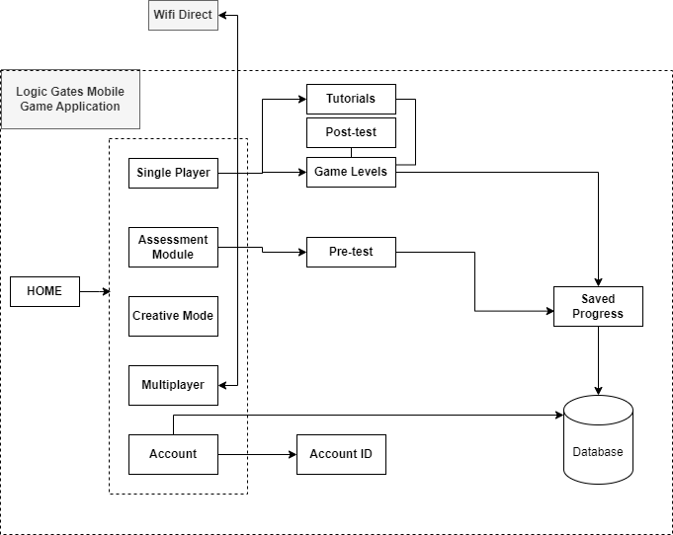

Figure1: Logic Gates Mobile Game Conceptual Framework

1. **Single player**

First of all, in the single player mode this will be the introduction and the background of the game that contains levels, tutorials, and post-test. In post-test after playing some of the levels of the game including pre-test, users can take post-test to evaluate their outcome. The post-test includes the questions that reflect the topics covered in the game levels assessing the user’s ability to apply the logic gate principles in different scenarios.

1. **Assessment Module**

In assessment module it includes the pre-test. In the pre-test users take a pre-test to gauge their baseline knowledge of logic gates and digital circuits. Questions and puzzles are presented to assess the user’s understanding of fundamental concepts.

1. **Creative Mode**

In Creative mode, users can experiment with logic gates freely. They can design and construct their own digital circuits, test their functionality, and observe the output. This mode encourages exploration and hands-on learning, allowing the users to reinforce their understanding of logic gates through practical experimentation.

1. **Multiplayer**

In multiplayer mode offers users the opportunity to engage in real-time competition with other players, fostering a sense of camaraderie and motivation to excel in logic gate challenges. Users can join or host multiplayer challenges where they compete against each other in solving logic gate puzzles or constructing circuits. Therefore, the system need an internet connection.

1. **Accounts**

User accounts allow players to have unique identities within the game, which is essential for saving progress and multiplayer interactions. With user accounts, users can create and customize profiles.

1. **Wifi Direct**

Wifi Direct allows mobile games to discover and connect to nearby devices within the Bluetooth range. This can be used to facilitate various gameplay features such as device synchronization, or sharing game content between players.

## Theoretical Framework

1. **LogIO: An Adaptive Gamification Learning Approach on Digital Logic Gates (2020).** “In contemporary education, e-learning is widely utilized, particularly in higher education, to enhance teaching and learning experiences. One effective method to achieve this is through gamification, which aims to increase effectiveness, motivation, performance, and overall learning experience for students. While gamification has gained popularity in higher education, integrating it properly is crucial for its positive impact on both teaching and learning processes, leading to increased satisfaction, motivation and engagement among learners. Despite numerous studies providing various game design elements, determining which specific elements truly influence learner motivation, performance, and learning experience remains a challenge. Therefore, employing game design principles effectively is essential in motivating learners, subsequently leading to improved learning outcomes. In fields like teaching digital logic gates, where complex concepts require hands-on demonstrations, gamified approaches have shown promise. In the Philippines, The Department of Education Secretary Leonor M. Briones, advocates for the adoption of innovative teaching methods, emphasizing the need for ICT instructors to utilize strategies that promote creativity and motivation among learners, signaling a timely adoption of gamification in education. Numerous studies have explored various game design elements, which can complicate the development and implementation of a gamified logic gate application. This study aims to identify most significant and relevant game design elements for the development of the gamified LogIO. Key elements such as story and rules, points, levels, challenges, leaderboards, and time constraints were identified as crucial for this purpose. For instance, the game begins with presenting the story and rules, followed by the player earning points and progressing through level before advancing, maintaining engagement. Completing challenges unlocks rewards for enhanced performance and learning experiences. Leaderboards are incorporated to boost motivation through ranking and statistics. Additionally, time constraints are introduced to gauge player performance and facilitate learning. Overall, these carefully selected game design elements aim to optimize player engagement and learning outcomes in the gamified application.”

**Reference**

[JO Torio, RT Bigueras, D E Maligat, Jr. , MA Arispe, and JS Dela Cruz .2020. LogIO: An Adaptive Gamification Learning Approach on Digital Logic Gates .2020.](https://iopscience.iop.org/article/10.1088/1757-899X/803/1/012008/pdf)

<https://iopscience.iop.org/article/10.1088/1757-899X/803/1/012008/pdf>

1. **Learning logic gate through 7 gates (2020).** “This game offers as simple yet effective method for students to learn about logic gates through an educational game with futuristic adventure theme. It aims to address the evolving educational needs, especially concerning high technologies and industry In Malaysia, secondary schools have begun teaching about logic gates, promoting game designers to cater to teenagers and educational needs. The game provides an opportunity for gaming enthusiasts to engage in beneficial gaming enthusiast to engage in beneficial experiences. It stands out by using a digital circuit theme and allowing users to explore a digital world imagined by the developers. The gameplay involves a simulation followed by puzzle-solving, with challenges like collecting switches. Progression through levels is contingent upon completing task and answering logic gate questions correctly. Key mechanics, such as locked levels, questions retries, switch collection, and levels restarts, are seamlessly integrated into the gameplay facilitate learning without explicit explanation to the players. As the game currently comprises levels, the developers aim to enhance it further if given the opportunity, aligning with future educational needs and technological advancements. ”

**Reference**

[Hanasrullah Halim, Wan Amirah Najwa Wan Idris, Haslina Hassan, Ismail Yusuf Panessai.2020. Learning Logic Gates through 7-Gates](Hanasrullah Halim, Wan Amirah Najwa Wan Idris, Haslina Hassan, Ismail Yusuf Panessai.2020. Learning Logic Gates through 7-Gateshttps://lamintang.org/journal/index.php/ijmari/article/view/70/51)

[https://lamintang.org/journal/index.php/ijmari/article/view/70/51](Hanasrullah Halim, Wan Amirah Najwa Wan Idris, Haslina Hassan, Ismail Yusuf Panessai.2020. Learning Logic Gates through 7-Gateshttps://lamintang.org/journal/index.php/ijmari/article/view/70/51)

Both research studies aims to enhance learning experiences through gamification, particularly in teaching digital logic gates. However, they have different approaches and implementations.

When it comes to engagement and motivation, LogIO: An Adaptive Gamification Learning Approach on Digital Logic Gates (2020) utilizes a variety of gamification elements such as points, levels, and leader boards, which are known to enhance motivation and engagement. Learning logic gate through 7 gates (2020) relies on puzzle mechanics to engage learners. While this can be engaging, it may not have the same level of motivation reinforcement as the structured gamification elements in LogIO.

When it comes to learning progression, the logIO (2020) provides the structured progression through levels, ensuring that learners master concept s before advancing. This guided practice approach can be beneficial for learning complex topics like digital logic gates. Learning logic gate through 7 gates (2020) offers a simulation and puzzle platform, but it lacks the clear progression seen in LogIO (2020). Learners may progress at their own pace, which could lead to gaps in understanding.

In feedback feature, LogIO (2020) offers immediate feedback through points, rewards, and leaderboards, reinforcing correct actions and motivating learners to continue. Learning logic gate through 7 gates (2020) provides feedback through retrying questions and consequences for incorrect answers, which may be less immediate and motivating compared to the feedback mechanisms in LogIO (2020).

Based on comparison, LogIO (2020) appears to be more relevant for learning digital logic gates. Its structured gamification elements, immediate feedback, and clear learning progression provide a more robust framework for enhancing motivation, engagement, and learning outcomes and most of its features is similar to our proposed title. Our approach is to improve our proposed study by analyzing the strategies of the other related studies. Therefore we need to consider incorporating a comprehensive evaluation methodology similar to LogIO. This could involve pre-test and post-test, surveys, and qualitative feedback to measure the game’s impact on student learning outcomes.

Explore ways to relate the content and objectives of the game to computer science. This can improve the applicability and relevance of the game for students. Include learning analytics and must include tools in the game that allow the users to monitor the progress and results to offer students insightful information. In collaborative learning we must look for ways to include components of collaborative learning in the game so that students can cooperate to share knowledge and solve problems by playing the game together.

This can strengthen understanding and develop collaboration. The proposed study must conduct a longitudinal studies to evaluate the lasting effects of the educational game on student’s learning outcomes and their career paths within the field of computer science. By tracking student’s progress and observing how their knowledge and skills develop over an extended period, we can gain valuable insights into the game’s long-term effectiveness. This assessment can help determine if the game has a sustainable positive impact on student’s educational achievements and career choices in the field of computer science.

# CHAPTER III METHODOLOGY

## Research Design

**Research Problem:**

How does the integration of logic gates into educational games impact players' understanding of digital logic concepts and problem-solving abilities?

This research problem addresses the effectiveness of educational games in teaching digital logic concepts, particularly through the incorporation of logic gates. Understanding how gameplay experiences influence players' comprehension of digital logic principles is crucial for designing effective educational interventions.

**Review previously published literature:**

Studies examining the effectiveness of educational games in teaching digital logic concepts compared to traditional instructional methods.

Research assessing the engagement levels of students when learning digital logic through games versus other forms of instruction.

**Hypothesis:**

Null Hypothesis (H0): The integration of logic gates into educational games has no significant impact on players' understanding of digital logic concepts and problem-solving abilities.

Alternative Hypothesis (H1): The integration of logic gates into educational games positively influences players' understanding of digital logic concepts and problem-solving abilities.

**Required data and how it will be obtained:**

**Pre-test and Post-test Assessments:**

Scores on assessments measuring players' understanding of digital logic concepts and problem-solving abilities before and after engaging with the educational game.

Participants will undergo pre-test assessments to establish baseline knowledge and skills in digital logic. After playing the game, post-test assessments will be administered to measure any changes in understanding and problem-solving abilities.

**Player Feedback and Surveys:**

Qualitative feedback from players regarding their experiences with the educational game, including perceived enjoyment, difficulty, and usefulness for learning digital logic.

**Performance Metrics:**

Objective performance metrics derived from players' interactions with logic gate-based puzzles or challenges within the game, such as accuracy in completing tasks, efficiency in solving problems, and adaptability to new scenarios

**Narrative description of the methods of analysis for testing the hypothesis:**

Firstly, a comparative analysis will be conducted between participants who engaged with the logic gate-based educational game and those who did not. Pre-test and post-test scores will be compared between these groups using statistical tests such as independent t-tests or analysis of variance.

Additionally, a correlation analysis will be performed to examine the relationship between gameplay metrics and learning outcomes. By calculating correlations between metrics like time spent playing or levels completed and post-test scores, we can assess whether higher engagement with the game correlates with better understanding of digital logic concepts and problem-solving abilities.

## Respondents

**Students**

Students are key stakeholders as they are the end-users of the logic gates game. Their input is crucial for understanding the level of engagement, effectiveness, and usability of the system in learning digital logic principles.

**Game Developers**

Their expertise can ensure that the system meets industry standards and provides an enjoyable gaming experience.

**Teachers**

Their feedback can validate the need for such a system in enhancing student understanding of digital logic concepts.

## Data Gathering Instruments, Techniques, and Procedures

Our online survey form for gathering data on logic gates game development begins with an introduction that explains its objective. It collects demographic data and evaluates players' experience with logic gate games. Questions assess perceptions, preferences, and feedback regarding game elements and learning outcomes. Open-ended sections allow participants to provide further comments and suggestions. The survey ends with a note expressing gratitude and a promise of privacy.

## Statistical Tools

**Statistical Software Packages:**

SPSS: For conducting various statistical analyses such as t-tests, ANOVA, regression analysis, and descriptive statistics.

R: Comprehensive statistical computing environment with packages for a wide range of analyses including hypothesis testing, linear modeling, and data visualization.

Python with libraries: Utilize libraries such as pandas, numpy, scipy, and scikit-learn for statistical analysis, machine learning, and data manipulation tasks.

## Analytical Tools

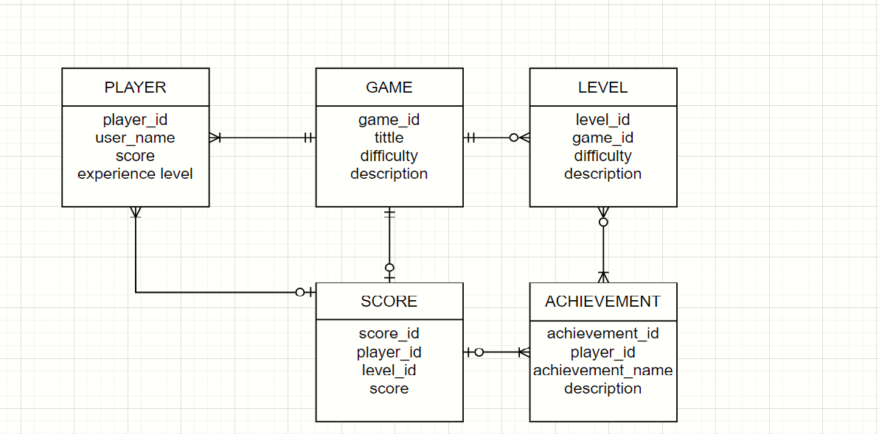

## Technical Tools

**Programming Languages:**

Various programming languages are used in game development to implement game logic, mechanics, and interactions.

C#, C++, and JavaScript are commonly used languages for scripting gameplay in Unity, while Unreal Engine primarily utilizes C++ for coding game logic.

**Hardware Devices:**

Hardware devices such as computers, consoles, smartphones, and tablets are used for testing and deploying games on various platforms etc…

## Software Process Model

The conception stage of the logic gates game creation process involves identifying the goals and intended player base of the game. After that comes design, where visual components and game mechanics are described to make sure they fit with the ideas of digital logic. Game mechanics are coded, visual assets are made, and instructional components are incorporated all within the development process. Testing and iteration improve user feedback and playability before being deployed on several platforms. Ongoing improvements and maintenance are guided by evaluation, which evaluates player involvement and instructional value. Using this process, programmers create entertaining logic gate games that both effectively teach digital logic fundamentals and offer a fun gaming experience.

## System Architecture

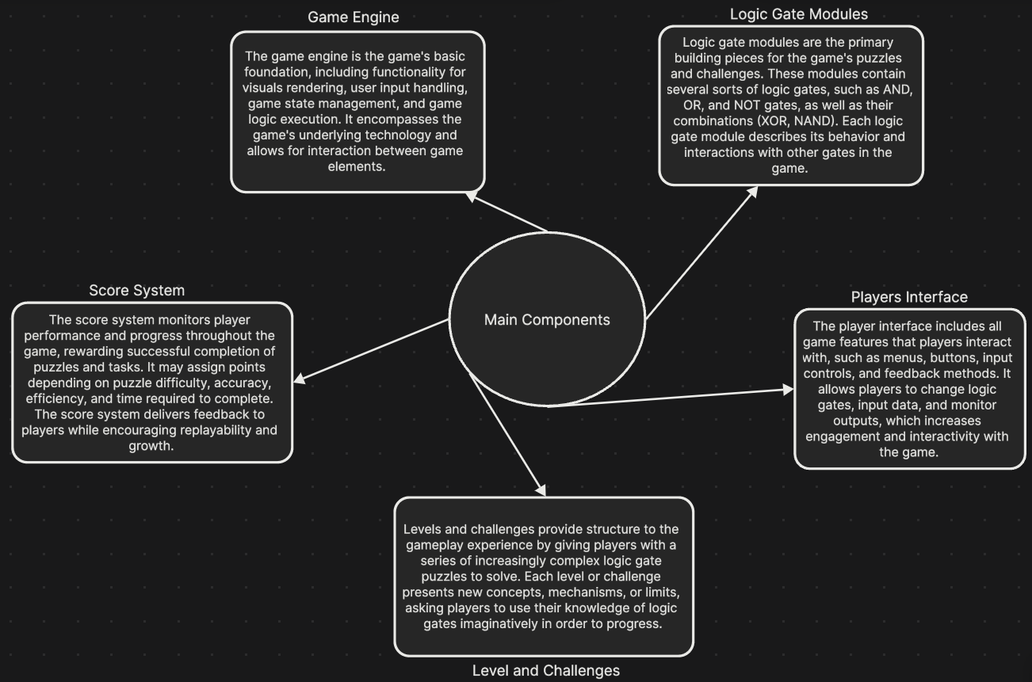

## Deployment and Testing

The deployment strategy for our logic gates game system includes concluding development, guaranteeing compatibility with target platforms, distributing via selected channels, and offering customer support.

For Testing Strategies to assure reliability and user satisfaction, testing methodologies include functional, compatibility, performance, usability, and security tests. Through these processes, creators ensure a smooth transition to actual usage while fixing any faults and optimizing the game for an interesting and informative experience

**Appendix A: Gantt Chart**

**A – PROJECT WORKPLAN**

**(1) Program Title**

**(2) Project Title: Gate Keeper: A Game-Based Approach to Logic Gates Learning in Higher and Secondary Education**

**(3) Project Duration (number of months):** ______12______

**(4) Project Start Date: January 1, 2024**

**(5)** **Project End Date: December 31, 2024**

|  |  |  |  |  |  |  |  |
| --- | --- | --- | --- | --- | --- | --- | --- |
| **(6) OBJECTIVES** | **(7) TARGET ACTIVITIES** | **(8) TARGET ACCOMPLISHMENTS**  (quantify, if possible) | **Y1** | | | | |
| **Q1** | **Q2** | **Q3** | **Q4** | **Total** |
| Analyze Current Educational Practices | Review existing educational materials on logic gates. | Identify key teaching methods and concepts used in current materials. |  |  |  |  |  |
| Analyze online lectures and platforms for effective teaching strategies. | Compile a list of effective online teaching strategies and their applications. |  |  |  |  |  |
| Collaborate with educators specializing in logic gates for insights and challenges. | Gather insights and challenges faced by educators in teaching logic gates. |  |  |  |  |  |
| Develop an Interactive Logic Gates Game | Design game mechanics and levels. | Develop a detailed plan outlining the game's mechanics and levels. |  |  |  |  |  |
| Develop visual and interactive elements for the game. | Create high-quality visual and interactive elements for the game. |  |  |  |  |  |
| Integrate educational content on logic gates into the game. | Integrate educational content seamlessly into the game mechanics and levels. |  |  |  |  |  |
| Conduct beta testing with students to gather feedback. | Obtain feedback from students to improve the game's functionality and educational value. |  |  |  |  |  |
| Evaluate the Effectiveness of the Game | Design pre-and post-test evaluations to measure student learning outcomes. | Develop assessments to measure student understanding before and after playing the game. |  |  |  |  |  |
| Collect data from beta testing to assess the game's impact. | Gather data on the game's impact on student learning and engagement. |  |  |  |  |  |
| Analyze data to determine the game's effectiveness in teaching logic gates. | Analyze collected data to determine the game's effectiveness as an educational tool. |  |  |  |  |  |
| Refine and Improve the Game Based on Feedback | Review feedback from beta testing and evaluation results. | Identify key areas for improvement based on feedback. |  |  |  |  |  |
| Identify areas for improvement in the game. | Determine specific aspects of the game that need improvement to enhance the learning experience. |  |  |  |  |  |
| Implement changes to enhance the game's effectiveness and engagement. | Make necessary changes to the game based on feedback and evaluation results. |  |  |  |  |  |
| Conduct additional testing to ensure improvements are effective. | Test the game after implementing changes to ensure improvements have been effective. |  |  |  |  |  |

**Appendix B: Survey Form**

1. How familiar are you with logic gates and basic digital circuits?
   1. Very familiar
   2. Somewhat familiar
   3. Not familiar at all
2. Have you ever used any educational games to help you gain knowledge?
   1. Yes
   2. No
3. Have you ever used any educational tools or games to learn about logic gates or digital circuits before?
   1. Yes
   2. No
4. What do you hope to achieve by playing a logic gates game?
   1. Gain a better understanding of how logic gates work
   2. Improve problem-solving skills
   3. Learn to design and analyze digital circuits
   4. Other (please specify)
5. How would you rate your interest in puzzle-solving games?
   1. Very interested
   2. Somewhat interested
   3. Not interested
6. What platform(s) do you prefer for playing games?
   1. PC
   2. Mobile (iOS/Android)
   3. Console (PlayStation, Xbox, etc.)
7. How important is it for you to have a visually appealing interface in a game?
   1. Very important
   2. Somewhat important
   3. Not important
8. Would you prefer a single-player or multiplayer mode for the logic gates game?
   1. Single-player
   2. Multiplayer
   3. Either is fine
9. How challenging would you like the game to be?
   1. Very challenging
   2. Moderately challenging
   3. Mildly challenging
10. Do you prefer a storyline or narrative in the game, or are you more interested in straightforward gameplay?
    1. Prefer storyline/narrative
    2. Prefer straightforward gameplay
    3. No preference
11. What additional features would you like to see in a logic gates game?

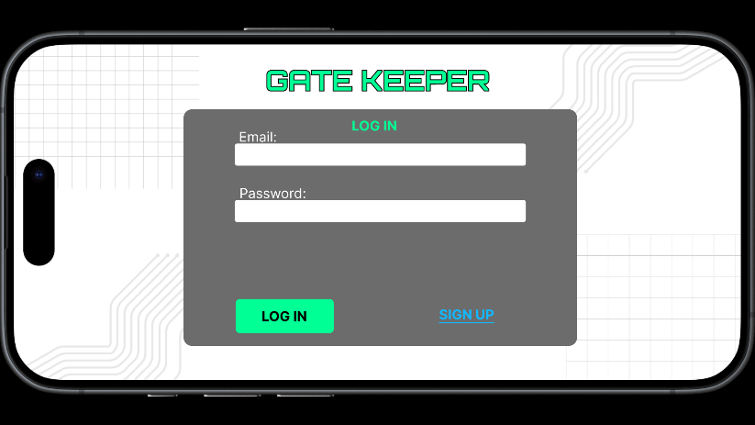**Appendix C: User Interface**

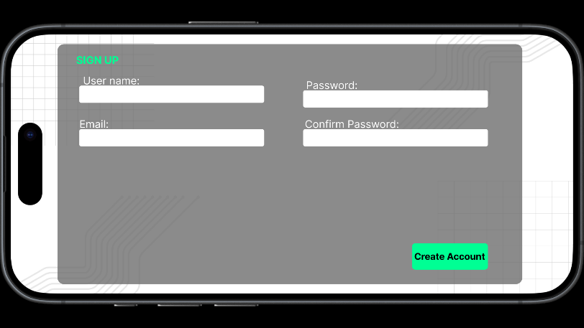

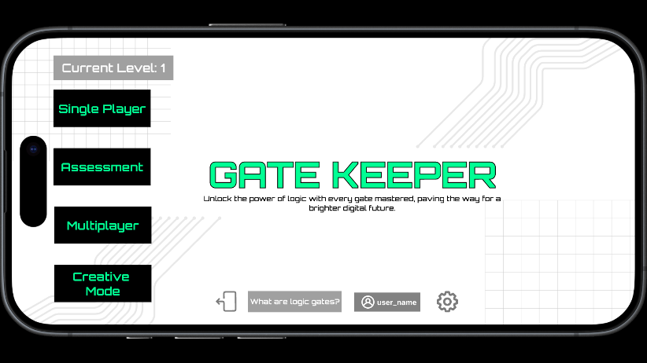

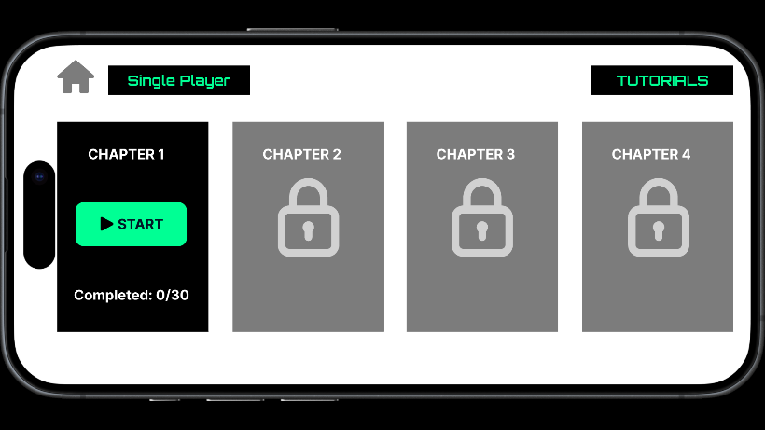

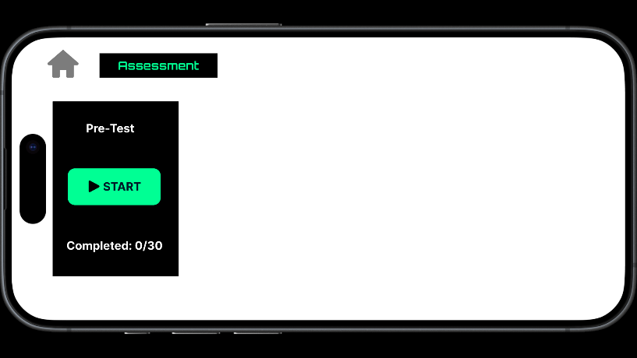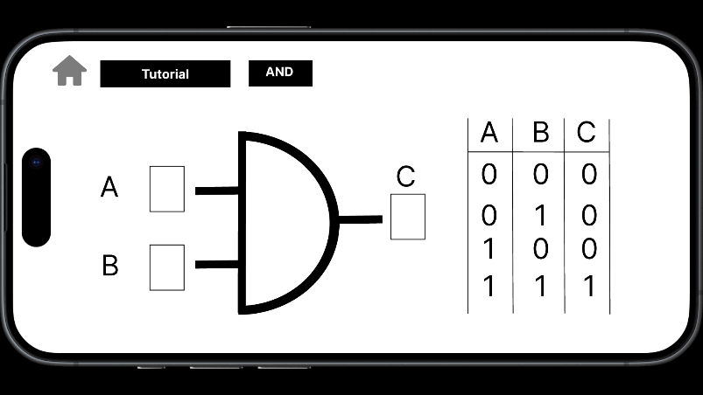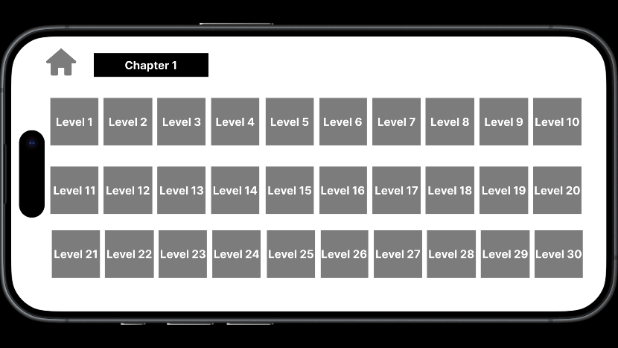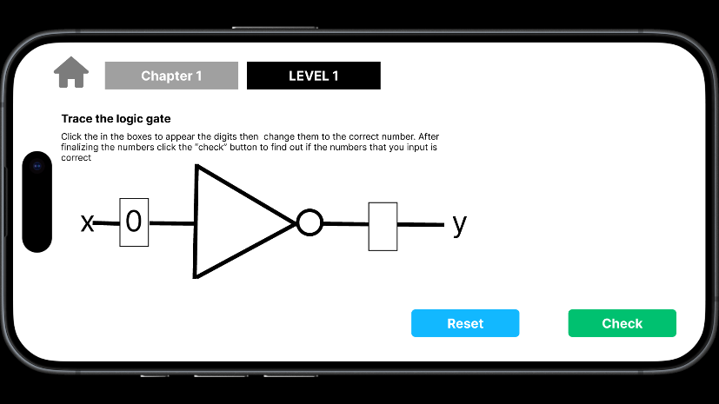

**Appendix D: Test Cases**

**Functionality Test Cases:**

**1. Input Validation:**

* Test that the game handles invalid input correctly (e.g., entering incorrect logic gate inputs).
* Verify that the game provides appropriate error messages for invalid inputs.

**2. Logic Gate Operations:**

* Test the functionality of each logic gate (e.g., AND, OR, NOT) to ensure they perform the correct operations.
* Verify that the game produces the correct output based on the input logic gates.

**3. Level Progression:**

* Test the game's ability to advance to the next level after completing a level successfully.
* Verify that the game displays the correct level progression and unlocks new levels as expected.

**Performance Test Cases:**

**1. Load Testing:**

* Test the game's performance under different load conditions (e.g., varying numbers of players, levels, and complexity).
* Verify that the game maintains acceptable performance levels without lagging or crashing.

**2. Resource Utilization:**

* Test the game's resource utilization (e.g., memory, CPU) to ensure it does not exceed acceptable limits.
* Verify that the game optimally utilizes resources for smooth gameplay.

**Security Test Cases:**

**1. Data Encryption:**

* Test the game's data encryption methods to ensure sensitive information is protected.
* Verify that the game uses secure encryption algorithms and practices.

**2. Authentication and Authorization:**

* Test the game's authentication and authorization processes to ensure only authorized users can access certain features.
* Verify that the game implements secure authentication mechanisms.

**3. Network Security:**

* Test the game's network security measures to protect against unauthorized access and data breaches.
* Verify that the game uses secure protocols and encryption for network communication.

**Conclusion:**

These test cases are designed to ensure the functionality, performance, and security of the logic gates game. By thoroughly testing these aspects, we can ensure a high-quality and reliable game for our users.

**Appendix E: Evaluation Tool**

Pre-Test Evaluation:

1. Objective: Measure students' baseline understanding of logic gates before playing the game.

2. Components:

* Multiple-choice questions on logic gate concepts.
* True/false questions on basic logic gate operations.
* Short-answer questions on logic gate applications.

Post-Test Evaluation:

1. Objective: Measure the impact of the game on students' understanding of logic gates.

2. Components:

* Multiple-choice questions on advanced logic gate concepts.
* True/false questions on complex logic gate operations.
* Short-answer questions on practical logic gate scenarios.

Survey:

1. Objective: Gather feedback on the game's usability, engagement, and educational value.

2. Components:

* Likert scale questions on game mechanics and interface.
* Open-ended questions on favorite aspects of the game and suggestions for improvement.
* Demographic questions on age, gender, and prior experience with logic gates.

Scoring:

1. Pre-Test and Post-Test: Scored based on correct answers.

2. Survey: Scored based on Likert scale responses and qualitative analysis of open-ended questions.

Conclusion:

The evaluation tool is designed to provide comprehensive feedback on the logic gates game, helping to identify its strengths and areas for improvement. By analyzing the results of the pre-and post-test evaluations and survey, we can assess the game's effectiveness in achieving its educational objectives and make informed decisions for future development.